Name:Qazybai Ali

Group: SE-2436

**Part 1. Introduction to HTML**

**Step 0. Create a new HTML file named index.html**

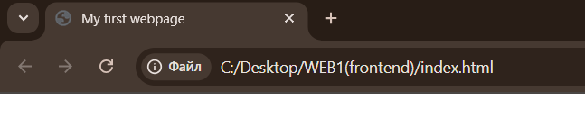

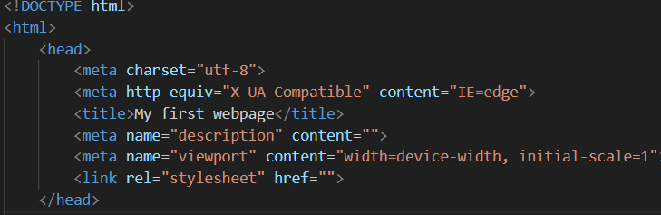

First of all I created a new HTML file named index.html to serve as the foundation of the project

**Step 1. Structure text using HTML tags**



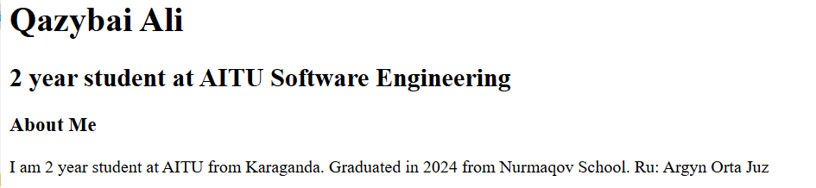

By using simple paragraph and heading tags I wrote about myself

**Step 2. HTML Lists**

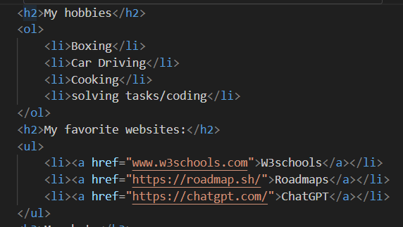

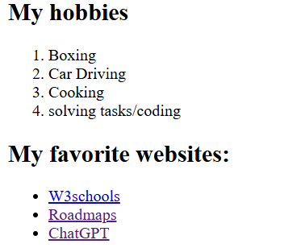

There are two types of lists which I created first is ordered list(ol tag) and unordered list(ul) so I created some list items

**Step 3. Images and Links**

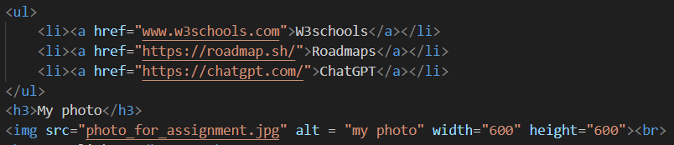

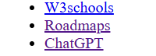I

I already paste the links to unordered list for don’t creating 2 similar lists just one for lists second for links

**Step 4. HTML Buttons**





Simple button provided with br tag to start the table with new line

**Part 2. Intermediate HTML**

**Step 5. Tables**

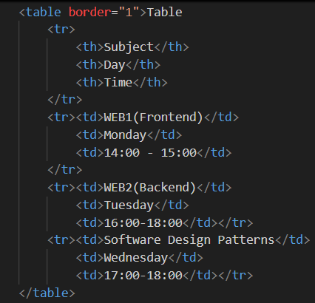

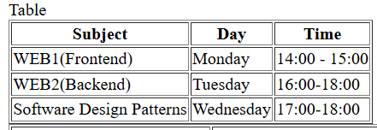

I’ve created the table with 3 columns. Tr means table row, td table data and th table head.

**Step 6. Optional Task**

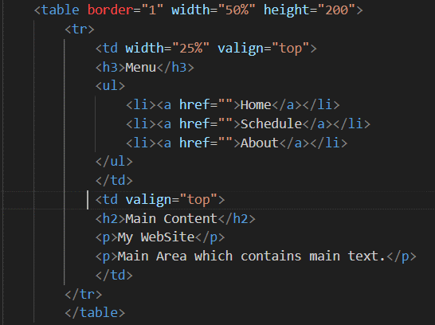

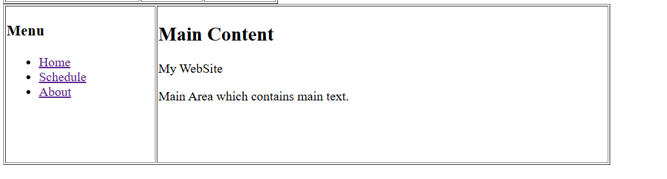

**Step 7. Typing Emojis**

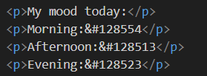

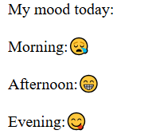

There are some symbols that means an exact emoji. It can be either numbers or with HEX type

**Step8. HTML Forms**

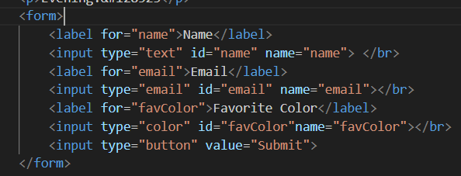

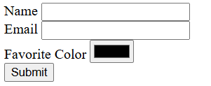

Forms were created using input fields, text areas, and buttons to let users provide information directly on the page. This made the website more interactive, allowing real user engagement and data collection instead of just displaying static content.

**Step 9. Publish Your First Website**

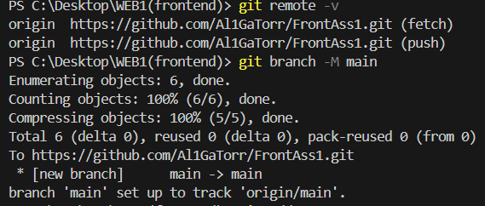

In conclusion this assignment work helped practice the core HTML skills needed for real web development